Instructions for Preparing Abstract for 7th Huixian International Forum on Earthquake Engineering for Young Researchers(7HXFEE)
1st Given Name Surname ¹, 2nd Given Name Surname ², and 3rd Given Name Surname ³
1 dept. name of organization (of Affiliation) City, Country (email address or ORCID)
2 dept. name of organization (of Affiliation) City, Country (email address or ORCID)
3 dept. name of organization (of Affiliation) City, Country (email address or ORCID)

This template is a guide to be used to prepare abstracts for submission. The length of the abstract should not exceed 2 pages inclusive of figures, tables, and photographs, if any. The abstract should be formatted for A4 size paper with 2.5cm margins on all four sides. For the title of the abstract, write all in capital letters using bold 14-point Times New Roman font centered and 25pt and 15pt added before and after the title, respectively. For the names of authors, use 12-point Times New Roman font centered, and for the author positions and affiliations, use 10-point Times New Roman font centered. The position, affiliation and e-mail address of each author should be listed. The hyperlink of the e-mail address should be deleted.

For the keywords use 12-point Times New Roman italic fonts left-aligned and should be 5 words keywords or less. The abstracts will be prepared in hardcopies and distributed to participants during the 7HXFEE. Please visit the 7HXFEE website (https://www.iem.ac.cn/7hxfee.html) and submit your abstract(s) online by July 15th, 2024.

Keywords: Earthquake, seismology, earthquake engineering, disaster (Keywords should be written in Italic.)

Figures should be numbered in sequence. Figures should be centred using the “7HXFEE Figure” style, and the figure should be positioned ‘in line with text’ using Layout Options.
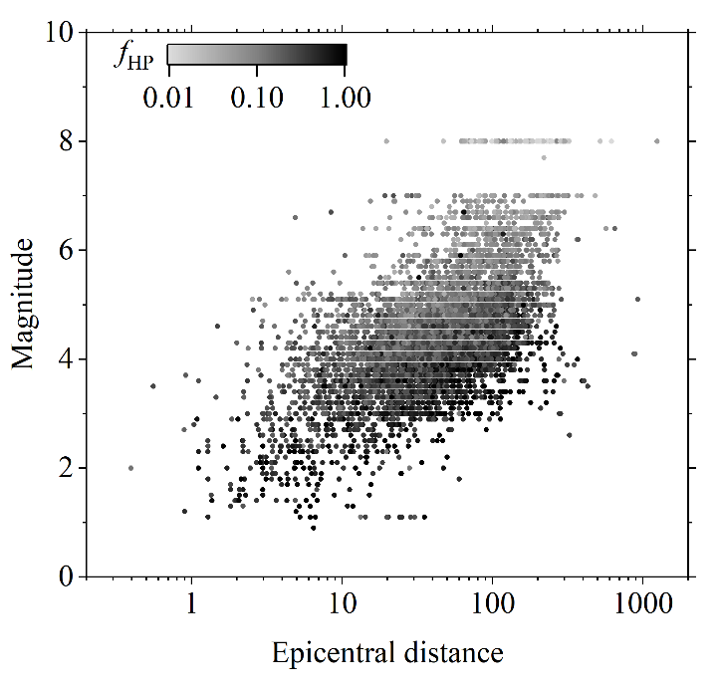
Figure 1. This is a figure
Table should be numbered in sequences.

Table 1. This is a table
TI  [units] | T2  [units] | T3  [units] | T  [units]
L1C1 | L1C2 | L1C3 | L1C4
L2C1 | L2C2 | L2C3 | L2C4
L3C1 | L3C2 | L3C3 | L3C4

Equations should be formatted by means of MathType Equation Editor or the inbuilt Microsoft Equation Editor. Equations should be centred and numbered consecutively. For example:
(1)

References
Boore, D. M., and Bommer, J. J., 2005. Processing of strong-motion accelerograms: needs, options and consequences. Soil Dynamics and Earthquake Engineering, 25(2): 93–115.

